Login to your Salesforce Organization and go to Setup

In order to make a Callout from the Apex code we can add the API we are going to use as a Named Credential. From Setup, go to Security 🡪 Named Credentials

We are adding the URL [https://api.nasa.gov/planetary/apod](https://empathetic-hawk-j7rvwg-dev-ed.trailblaze.my.salesforce.com/servlet/servlet.ExternalRedirect?url=https%3A%2F%2Fapi.nasa.gov%2Fplanetary%2Fapod)  
  
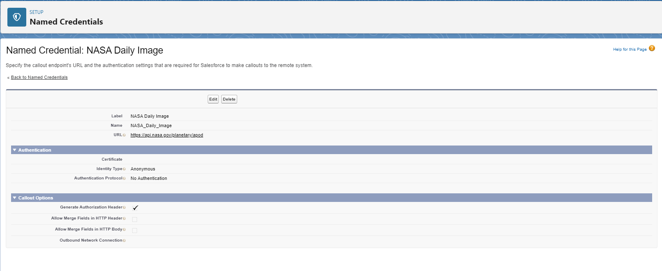

From Setup, go to Object Manager and create a new Custom Object.

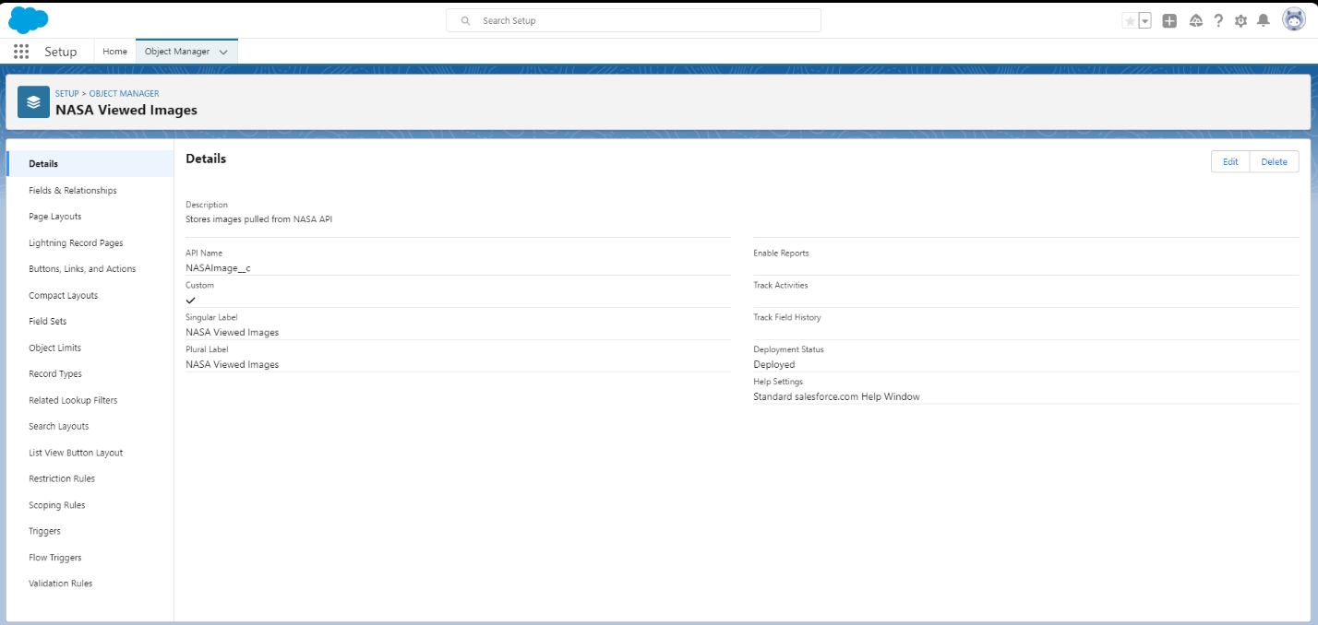

Create fields to hold data pulled from the NASA API. The data sample which the Apex code will collect looks like this:

{"date":"2021-05-21","explanation":"sive Utopia Planitia on Mars is strewn with rocks and boulders in this 1976 image. Constructed from the Viking 2 lander's color and black and white image data, the scene approximates the appearance of the high northern martian plain to the human eye. For scale, the prominent rounded rock near center is about 20 centimeters (just under 8 inches) across. Farther back on the right side of the frame the a dark angular boulder spans about 1.5 meters (5 feet). Also in view are two trenches dug by the lander's sampler arm, the ejected protective shroud that covered the soil collector head, and one of the lander's dust covered footpads at the lower right. On May 14, China\u2019s Zhurong Mars rover successfully touchdown on Mars and has returned the first images of` its landing site in Utopia Planitia.","hdurl":"https://apod.nasa.gov/apod/image/2105/vikinglander2-2.jpg","media_type":"image","service_version":"v1","title":"Utopia on Mars","url":"https://apod.nasa.gov/apod/image/2105/vikinglander2-2_1024.jpg"}

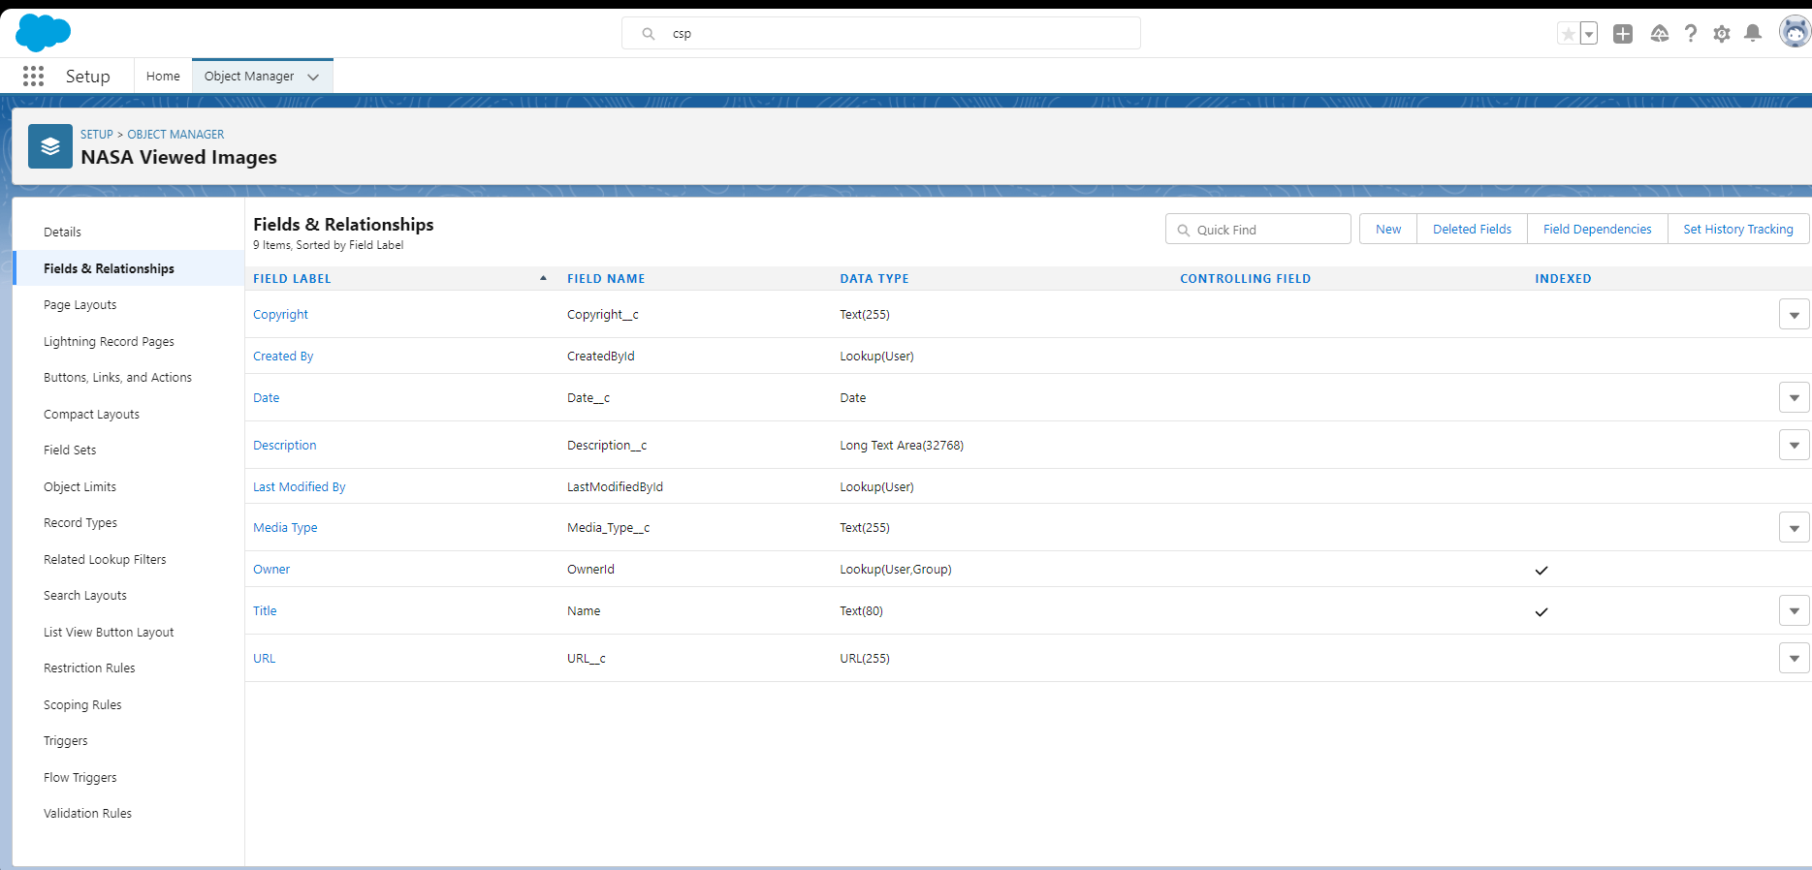

Create the page layout as desired.

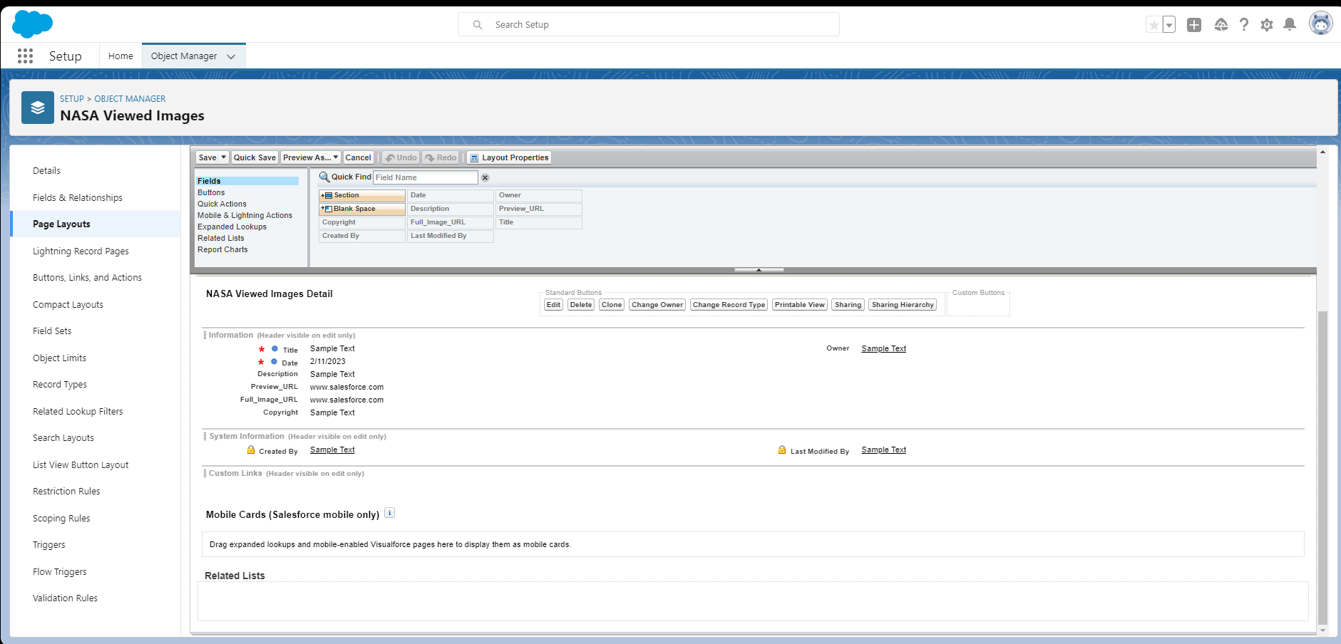

From Setup, go to User Interface 🡪 Tabs and add your Custom Object as a viewable Tab (if not already done)

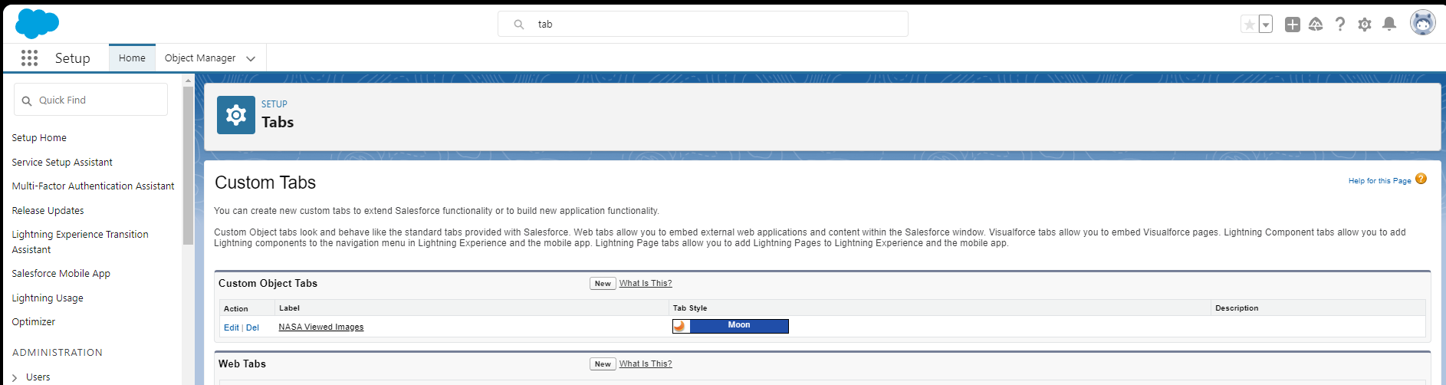

**\*\*\* AT THIS POINT YOU NEED TO HAVE ALL THE CODE FROM THE LIGHTNING WEB COMPONENT DEPLOYED \*\*\***

From Setup, go to User Interface 🡪 Lightning App Builder and create a new Lightning App Page to display your LWC.

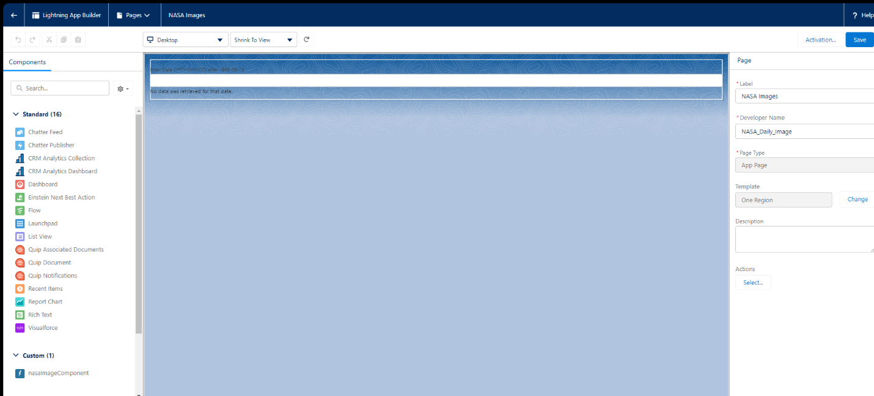

From Setup, go to Apps 🡪 App Manager and create a New Lightning App to display your Custom Object Tab and Lightning Web Component Page.

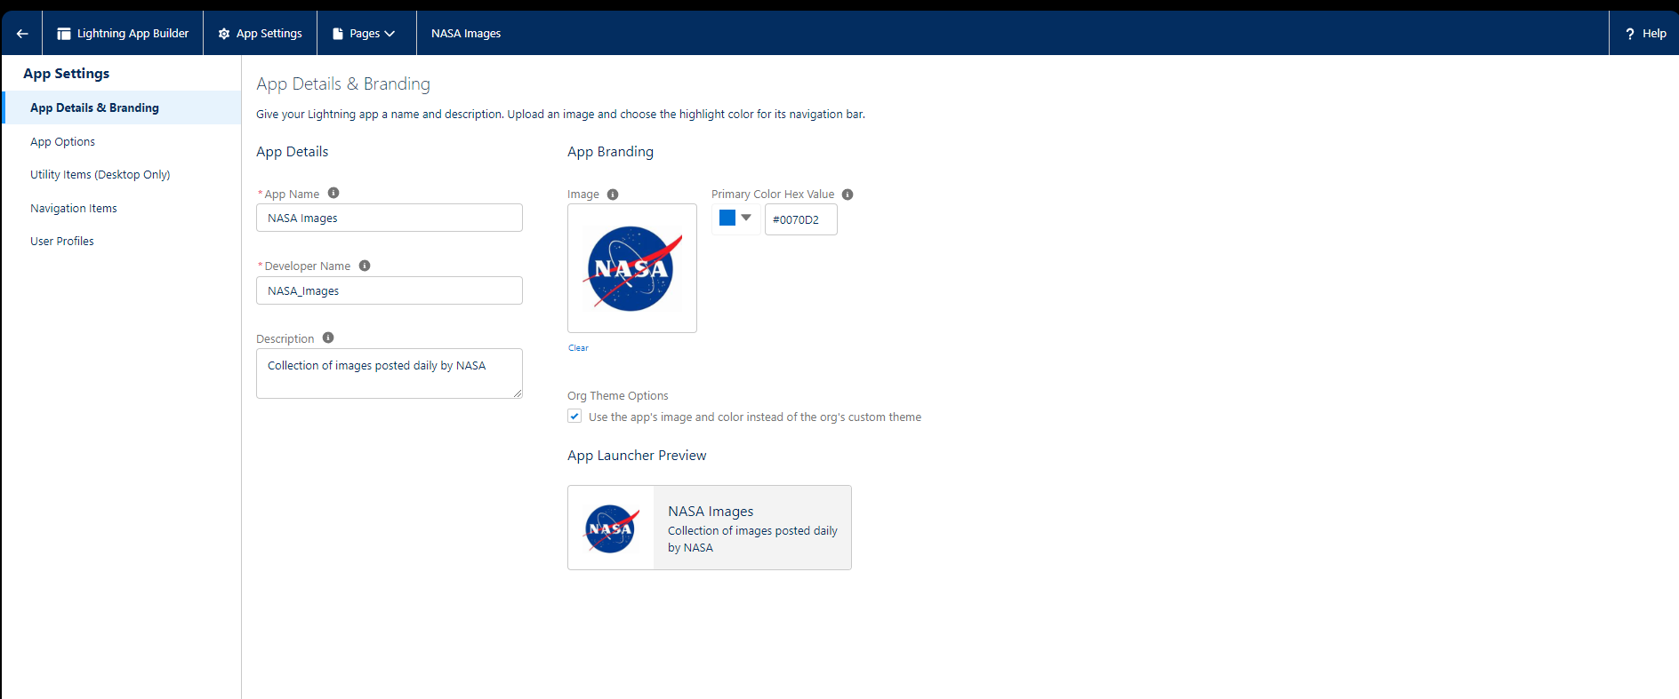

From Setup, go to Security 🡪 CSP Trusted Sites and add the URL as a trusted site.

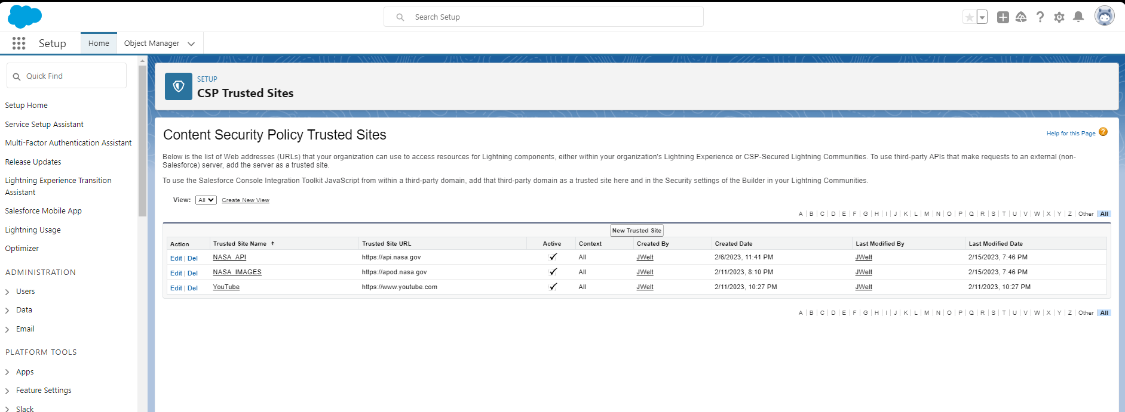

Open the Developer Console, and open an Anonymous Window. Type the code in the Image to schedule the code to run every day so that each daily image is saved to the custom object.

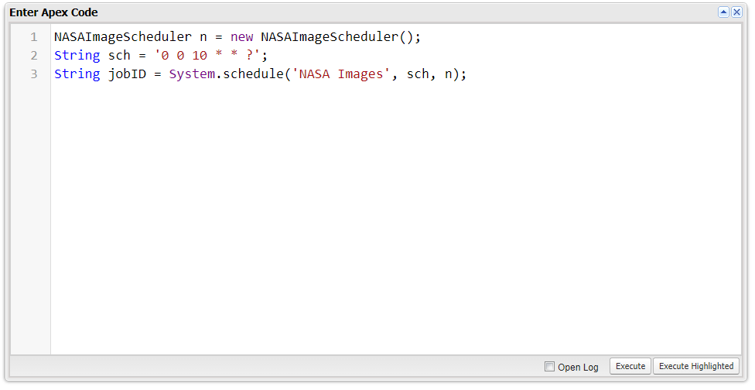

You can verify it is scheduled by going to Setup 🡪Environments 🡪 Jobs 🡪 Scheduled Jobs

